SETTING UP YOUR ACCOUNT

We recommend:

User ID: first.last

Password: h then your student ID number.

Returning Students
If you have an existing account for any Vista Higher Learning textbook, complete these steps:
- Go to vhlcentral.com
- Log in using your existing account information.
Enroll in the course by clicking the "Enroll in a course" link. Then complete "Step 4 - Select a Course/Class" below.

New Students
If you are new to Vista Higher Learning, complete these steps:
Step 1 - Go to vhlcentral.com

Step 2 - Create an Account
- Click the Create an account » link
- In the "Login Information" section of the account creation page, enter a username of your choice.
- Enter the email address you would like to associate with your account.
- Enter and confirm a password of your choice.
- In the "Personal Profile" section, enter your first and last name as you wish them to appear in your Instructor's roster.
- Select the year of your birth from the drop down list.
- Enter a student ID (optional).
- In the "Security Information" section, provide the answer to a secret question, which may later be used to help you access your account if you forget your password.
- After you enter all of the information, click "create an account."
- Click "agree." (Before your account is created, you must agree to the terms and conditions of use policy.)

Step 3 - Select a School
- Locate your school by typing your school’s name, Hillgrove High School. To narrow the search results, add the city and state, Powder Springs, GA , in which your school is located.
- Click "find." If the terms you entered did not result in a successful search, follow the on-screen tips to revise your search.
- Select your school from the list by clicking on its name.
- Click "select school" to add the school to your account.
- Look for a message at the top of the screen confirming you successfully added the school.
- Once you have selected the school, please click on the book DESCUBRE 2

Step 4 - Select a Course/Class
- From the list of available classes at your school for your textbook (Descubre 2), look for Instructor "Pulido" and the course "Native Speakers Third block/Native Speakers Fourth block. It should look like this:
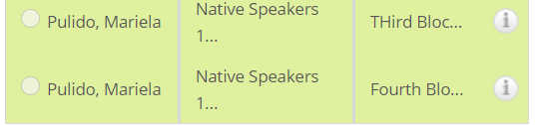
- Click the radio button for your block.
- Click enroll. You should see a confirmation that you successfully enrolled in your instructor's course.

