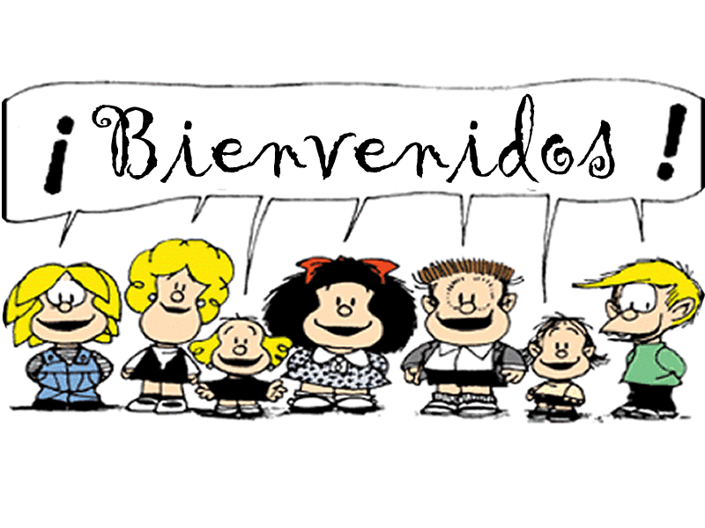

Honors Spanish 3

Contact Information

Teacher: Mariela Pulido
Planning: Second Block
Room Location: 2303
E-mail Address: mariela.pulido@cobbk12.org
Blog: Can be accessed through Hillgrove website under World Languages Department.
Remind: 81010 Text: @ekkfg3k

What do I need for Spanish class?
Participation
The most important thing you need this year is not something you will go out and purchase. It’s participation in class – every day that class meets. You need to be in class!!! If you miss class, you miss HUGE amounts of input in the language and practice. There may be incentives for good participation as well, so get involved
Supplies

- Pens/Pencils
- A Spanish-English Dictionary or WordReference app on cellphone.
- A three-ring binder with plenty of notebook paper, 5 tab dividers, & pockets.

Textbook
We will use Descubre 1 & 2 (Vista Publishing) in this course. Students will be receiving textbooks and access to the online Supersite found at www.vhlcentral.com during the first week of class. The textbook will be turn in at the end of the semester. Failure to return the textbook is subject to a replacement fee. All materials the students need, including an electronic version of the textbook, can be found online. I do not require that textbooks be brought to class.

How is my grade determined in this class?

Formative Assessments (15%)
Formative Assessments include daily practice & exercises, classwork, homework, rough drafts
Summative Assessments (30%)
Summative Assessments include vocabulary, grammar, listening & speaking quizzes
Formal Evaluations (40%)
Formal Evaluations include presentations, projects, and unit tests
Final Exam (15%)
Final Exam includes listening, speaking, reading, writing, grammar, vocabulary, & culture

For further information on the Spanish Curriculum and Standards, please go to:
https://www.georgiastandards.org/standards/pages/BrowseStandards/MLLStandards9-12.aspx
Expand the Modern Languages list. Click on Modern Languages Level II.

What are the class policies, procedures & expectations?

Make-up Policy & Restrictions
A student may make up all missed work for any absence. Students are allowed the number of days absent, plus one day to turn in ALL missed work. It is the student’s responsibility to schedule make-up appointments for quizzes and tests within the grace period before or after school. If an assessment has been announced prior to an absence, the student will take the assessment as scheduled. Teacher discretion will be used for extenuating circumstances.

Homework
Completed homework is due at the beginning of class. NO late work will be accepted except in the event of an absence. Homework will be assigned at various times throughout the week.

Extra Credit?
NO extra credit work will be given to substitute or take the place of another grade.

Hall Passes
Hall passes will be provided by the teacher. Students should use the restroom during class change, and instruction should not be interrupted except for emergencies. The first and last 15 minutes of class are “dead time” when no student is permitted to be in the hall.

Late Work Without Absence
If a student comes to class without a summative graded assignment (a project) on the day it is due, the following point deductions will apply:
One day late - 11 percentage points will be deducted
Two days or more late - A permanent grade of zero will be assigned.
Failure to complete a speaking presentation on the day it is assigned will result in a permanent grade of 0

Tutoring
Tutoring will be arranged on an individual basis before or after school. Students and/or parents should arrange with Ms. Pulido via email or phone call a time that is convenient to meet.

Classroom Expectations
1. Be attentive. 4. Be responsible. 7. Participate often.
2. Be courteous. 5. Be punctual. 8. Respect others, yourself, & the classroom.
3. Be prepared. 6. Follow handbook guidelines 9. Stay seated until dismissed
10. Speak Spanis
And remember…
- Selling fundraiser items must take place between classes.
- The use of electronic devices will be permitted at the teacher’s discretion only for specific instructional and educational purposes. Students may NOT have out or use their electronic devices during class time unless indicated by the teacher. Failure to follow the teacher’s directions will result in an insubordination referral, and will be handled by the administration.
- Please refer to the student handbook regarding all school and county policies.

Consequences
For most offenses the consequences are as follows:

1st Verbal warning 3rd Detention; Call Home; Conference
2nd Call Home; Conference 4th Administrative Referral

The teacher reserves the right to change consequences as needed based upon the severity of the individual situation. Disrespect of any kind for any reason will result in an immediate referral.

PARENTS & STUDENTS CAN SIGN UP FOR TEXT ALERTS WHICH WILL BE USED TO:
- Remind students of upcoming projects/tests/due dates
- Alert students to bring their textbook or other materials that will be needed for class on specific days

