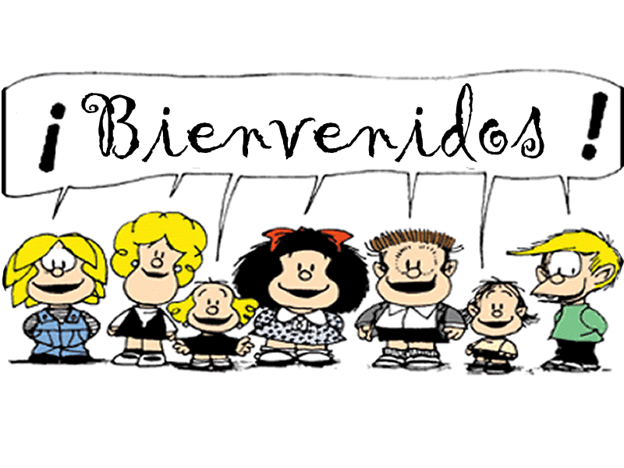

Honors Spanish 2

Contact Information

Teacher: Mariela Pulido
Planning: Third Block
Room Location: 2303
E-mail Address: mariela.pulido@cobbk12.org
Blog: Can be accessed through Hillgrove website under World Languages Department.
Remind: 81010 Text: @79f8a

What do I need for Spanish class?
Participation
The most important thing you need this year is not something you will go out and purchase. Participation in class – every day that class meets – is the most important aspect of the class. You need to be in class!!! If you miss class, you miss HUGE amounts of input in the language and practice. There are incentives for good participation as well, so get involved

Supplies

- Pens/Pencils
- Suggested apps: Word Reference, Flipgrid, Quizizz, Kahoot, Remind.
- A three-ring binder, dedicated to Spanish class with plenty of notebook paper, 5 tab dividers, & pockets.

Donations: I will happily take donations of the following items that are always useful in my classroom
- Kleenex tissues
- Hand sanitizer
- Yarn (any color, partial roll or new)
- Construction paper / tissue paper (gift wrap)
- Elmer’s school glue

Textbook
We will use Descubre 1 (Vista Publishing) in this course. The teacher will have a class set of books in the classroom for students to use. Students will receive access to the online textbook and Supersite found at www.vhlcentral.com during the first week of class.

How is my grade determined in this class?
We will grade on the four main aspects of language: reading, writing, listening and speaking. Each unit will end with a Formal Evaluation to show you have mastered the content.

Formative Assessments (15%)
Formative assessments are comprised of in-class activities, Pesos, VHL Central activities and homework. These will cover all areas of the language: Grammar & Writing, Vocabulary & Reading, Listening & Speaking, and Culture. All VHL Central Activities will count for a grade and will go into this category.

Summative (30%) – essays, projects, quizzes, skits

Formal Evaluations (40%) - chapter/unit tests and major projects and presentations, Talent Show

Final Exam (15%) – There will be 5 parts to the final exam: listening, speaking, reading, writing, grammar, vocabulary

For further information on the Spanish Curriculum and Standards, please go to:
https://www.georgiastandards.org/standards/pages/BrowseStandards/MLLStandards9-12.aspx
Expand the Modern Languages list. Click on Modern Languages Level II.

What are the class policies, procedures & expectations?

Cell Phone Policy
The use of electronic devices will be permitted at the teacher’s discretion only for specific instructional and educational purposes. Upon entry to the classroom, students will place their phones into their individual phone pouch located in the front of the classroom. 1st offense of having a phone out in class will result in a teacher warning. Following consequences will include parent contact with a teacher detention, a parent conference, and then a discipline referral.

Make-up Policy & Restrictions
When there is an absence, it is the student’s responsibility to schedule make-up appointments for quizzes and tests with the teacher before or after school. If an assessment has been announced prior to an absence, the student will take the assessment as scheduled. Teacher discretion will be used for extenuating circumstances.

Homework & Extra Credit
Completed homework is due when the teacher asks for it, typically at the beginning of class. NO late work will be accepted except in the event of an absence. NO extra credit work will be given to substitute or take the place of another grade.

Late Work Without Absence
If a student comes to class without a project (summative or formal evaluation) on the day it is due, a letter grade will be deducted from the overall project grade. A zero will be entered into Synergy until the assignment is submitted. If the project is not submitted before the end of the unit, a permanent grade of zero will remain in Synergy.

Tutoring
Tutoring will be arranged on an individual basis before or after school. Students and/or parents should arrange with Mrs. Erwin a time that is convenient to meet. A list of available peer tutors is also available upon request.

Classroom Expectations
1. Be attentive. 4. Be responsible. 7. Participate often.
2. Be courteous. 5. Be punctual. 8. Respect others, yourself, & the classroom.
3. Be prepared. 6. Follow handbook guidelines 9. Stay seated until dismissed
10. Speak Spanish!
And remember…
- Selling fundraiser items must take place between classes.
- Please refer to the student handbook regarding all school and county policies.

Consequences
For most offenses the consequences are as follows:

1st Verbal warning 3rd Administrative Referral; Call Home; Conference
2nd Call Home; Conference

The teacher reserves the right to change consequences as needed based upon the severity of the individual situation. Disrespect of any kind for any reason will result in an immediate referral.

PARENTS & STUDENTS CAN SIGN UP FOR TEXT ALERTS WHICH WILL BE USED TO:
- Remind students of upcoming projects/tests/due dates
- Alert students to bring materials that will be needed for class on specific days

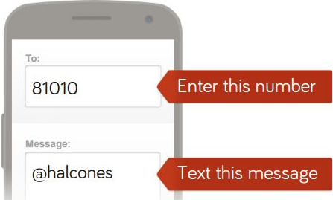
81010
@79f8a

