SETTING UP YOUR ACCOUNT - New Students

Step 1 - Go to www.vhlcentral.com

Step 2 - Create an Account
- In the "Login Information" section of the account creation page, enter your username as firstname.lastname (ex) mariela.pulido
(in case the username has already been taken by another student with the same name, try to put your birthday numbers after it. For example, if my name is Mariela Pulido and my birthday is Oct. 4th, I would make my username mariela.pulido104
- Enter the email address you would like to associate with your account (you may use any email address you’d like).
- Enter and confirm your password. Your password should be the letter “h” followed by your lunch number. (ex) h1264702
- In the "Personal Profile" section, enter your first and last name as you wish them to appear in your Instructor's roster.
- Select the year of your birth from the drop down list.
- Enter a student ID (optional).
- In the "Security Information" section, provide the answer to a secret question, which may later be used to help you access your account if you forget your password.
- After you enter all of the information, click "create an account."
- Click "agree." (Before your account is created, you must agree to the terms and conditions of use policy.)

Step 3 - Select a School
- Locate your school by typing your school’s name, “Hillgrove” in the search bar.
- Click "find." If the terms you entered did not result in a successful search, follow the on-screen tips to revise your search.
- Select your school from the list by clicking on its name.
- Click "select school" to add the school to your account.
- Look for a message at the top of the screen confirming you successfully added the school.

Step 4 - Select a Course/Class
- You will see a list of all available courses, classes, and teachers at your school that uses the Supersite. Select only the option that lists your Instructor, Course, and Section (block) correctly. For example, if you have Mrs. Pulido for Honors Spanish 2 during 2nd block, you would select the option below:
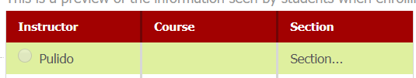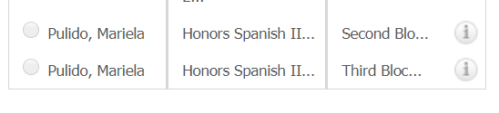

- Click Save. You should see a confirmation that you successfully enrolled in your instructor's course.

INSTRUCTIONS FOR STUDENTS WHO ALREADY HAVE A VHL CENTRAL ACCOUNT

Step 1 - Go to www.vhlcentral.com

Step 2 – Login to your Account
- Your username should be firstname.lastname (ex) Mariela.pulido
in case the username was already taken by another student with the same name, your account should have your birthday numbers
after it. For example, Mariela Pulido and my birthday is Oct. 4th, I would make my username mariela.pulido104
- Your password should be a lowercase “h” followed by your lunch # (ex) h1264702

Step 3 – Look at the top, right of the page and select “Enroll in a Course”
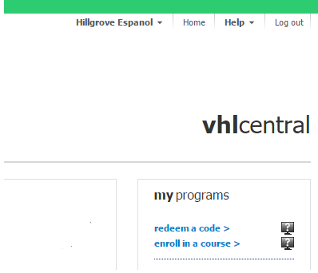

Step 4 - Select a Course/Class
- You will see a list of all available courses, classes, and teachers at your school that uses the Supersite. Select only the option that lists your Instructor, Course, and Section (block) correctly. For example, if you have Mrs. Pulido for Honors Spanish II during 3rd block, you would select the option below:
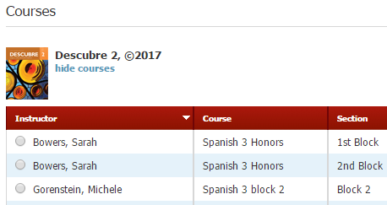
- Click Save. You should see a confirmation that you successfully enrolled in your instructor's course.

